Assignment 11:
- What is TMG?
- TMG => Table Maintanance Generator.
- TMG is a tool in SAP ABAP used to create a standard maintenance screen to insert, update, delete, and display records of a database table.

- Why TMG Is Used
- TMG is used to maintain table data easily, especially for custom tables and configuration tables.
It saves development time and ensures data consistency and authorization control.

- TMG is created using SE11 and accessed using SM30.

- Create TMG for 1 & 2 steps with separate TMG.
- Create 2 tables for 1step and 2step TMG.
- Enter Table name (Table 1) and click Change
- From the menu, select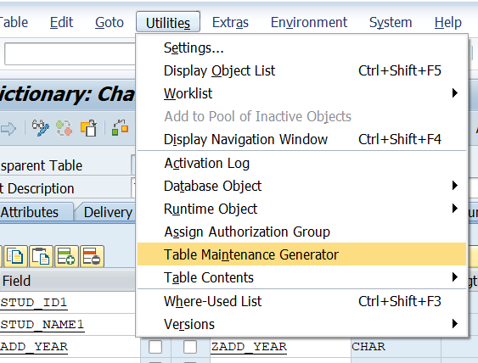
- Utilities → Table Maintenance Generator
- 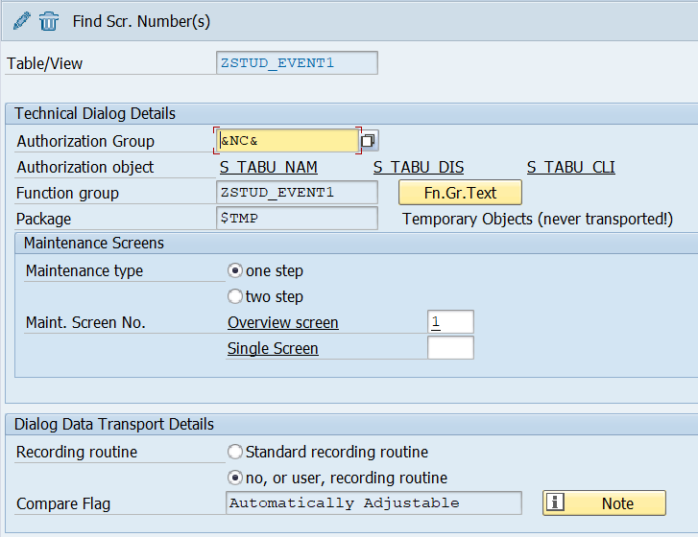
- Authorization Group:- &NC&
- Function Group:- table name (ZSTUD_EVENT1)
- Maintenance Type: One Step (recommended)
- Create and Activate.
- Select Find screen number and select Propose screen number(s)
- 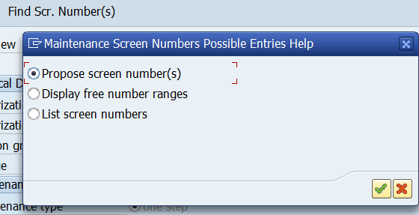

- Now create another table(ZSTUD_EVENT2)
- Create another TMG with same process
- And Select Maintenance type two step
- 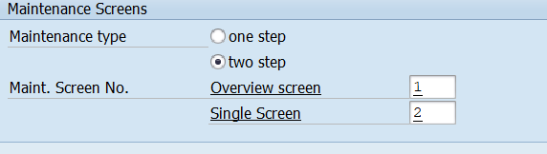

- Select Find screen number and select Propose screen number(s)

- Explore option button in TMG.
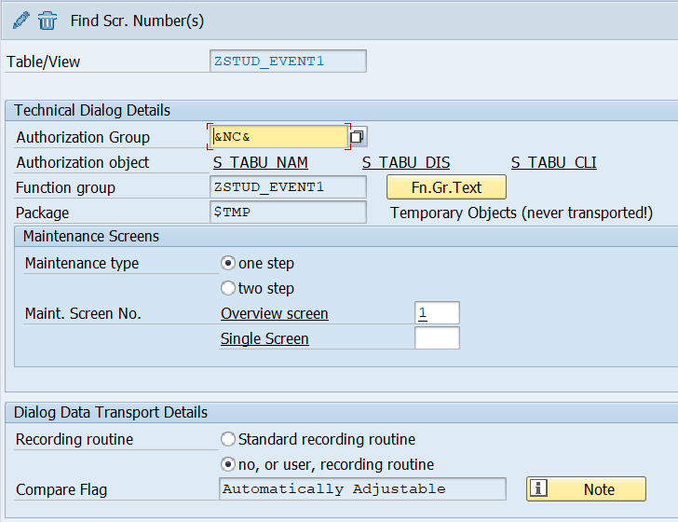
- Authorization Group:
- Controls who can maintain the table data in SM30.
- Example: &NC& → No authorization check
- Maintenance Type
One-Step Maintenance
- Overview + detail in single screen
- Simple and fast
- Used for small tables
Two-Step Maintenance
- Overview screen first
- Detail screen opens separately
- Better control for complex tables
- Dialog Data Transport Details
Recording Routine
Standard recording routine:
- Table entries are recorded in transport
- Used for configuration tables
No / User recording routine:
- Data is not automatically transported
- Used for transactional tables

- Create TMG with 5 events which include date, time, username & rest 2 anything as per requirement.
- First, we have to create a table(ZSTUD_EVENT2).
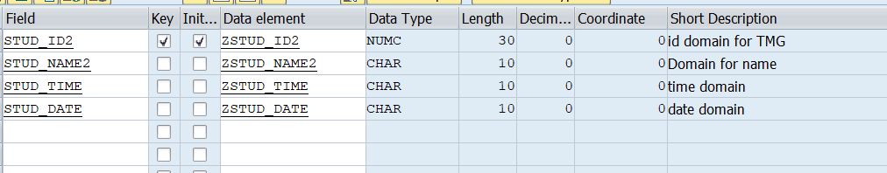
- Next, create table maintenance generator(TMG).

- Next go to Environment-> Modification-> Maintenance screen-> select the screen -> enter

- 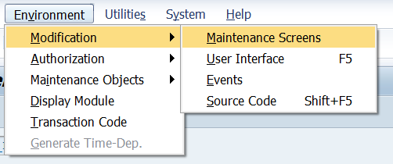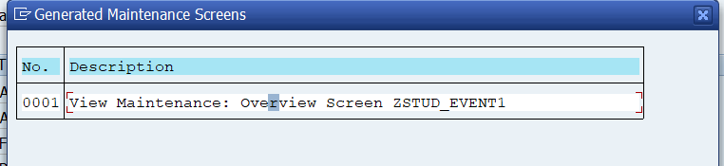

- Next Click on Layout
- 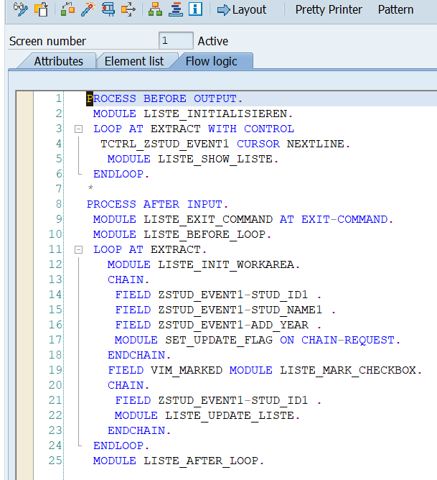
- After this Double click on time column and also for the date column and select program Outputonly.
- After click on flow logic and activate it.
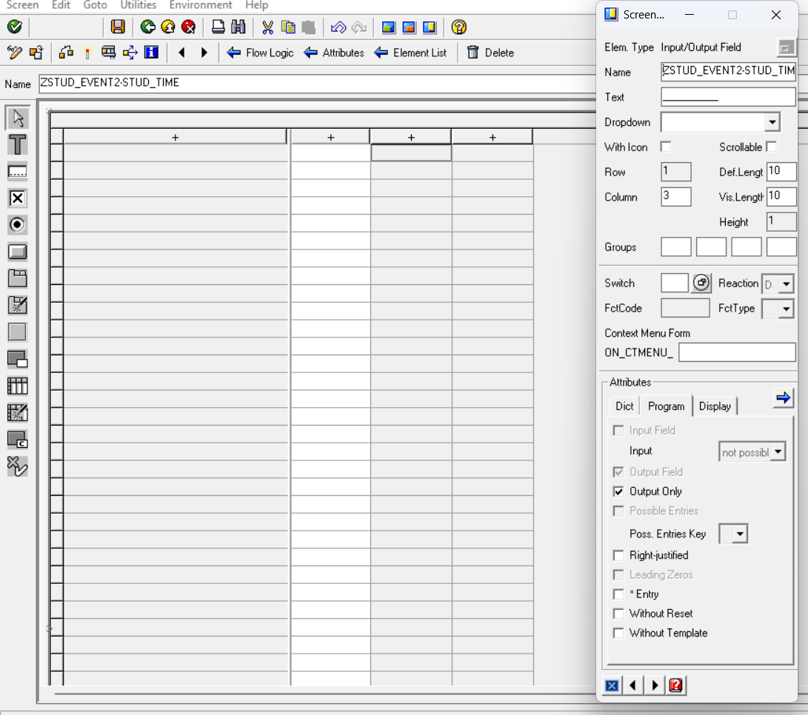
- Next create Events goto SE11->Environment->Modification->events->click

- New entries->Select event-> 05 create a new entry-> give name for FORM routine(INITIALIZE_DETAILS) -> ENTER -> after click on enter button, editor will be created -> click on editor.
- 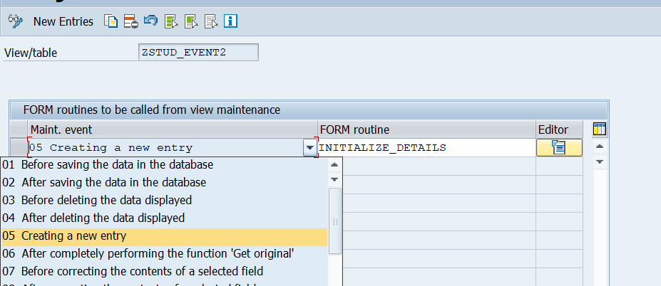

- After going to editor Write the program -> save and activate->
- 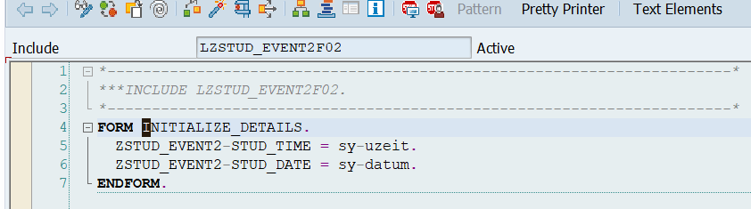

- Next goto table (ZSTUD_EVENT2) and create entries
- 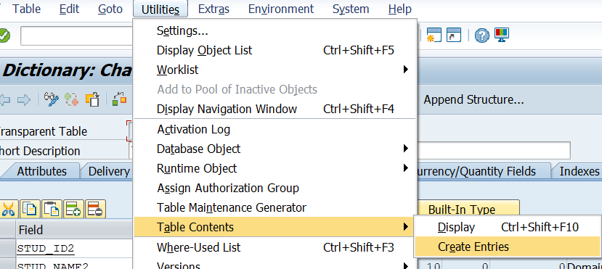
- 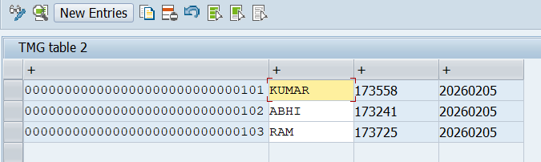

- Add details for ID and Name and time and date columns are filled automatically when we click ENTER.-> save and check the table records.
- 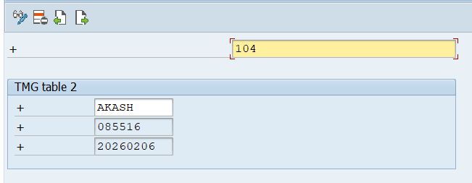

- 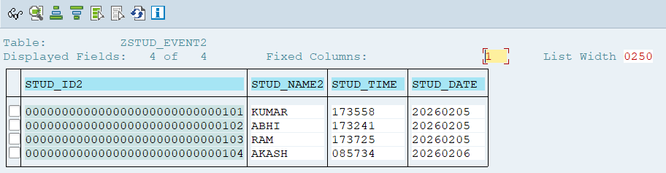

- Can we delete record present in the table after creating TMG?
- Yes, we can delete records after creating TMG.
- Using SM30 Tcode we can delete the records by selecting particular record.

- After creating TMG can we make particular records non editable?
- Yes,
- Go to SE11
- Enter table → Utilities → Table Maintenance Generator
- Click Environment → Modification → Events
- Use event:
- Before saving the data
- Before change of a record
- After entry in overview screen

